Surfscan

Chris Guarino Living Notes

Operations Manual

Procedure:

1. Ensure that you have the proper recipe selected.
   1. Likely HOT200mm
2. Ensure that recipe parameters are correct.

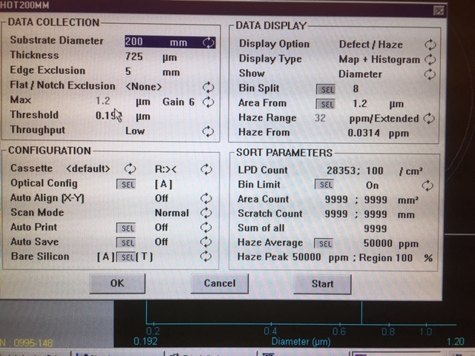

1. Load wafers to be measured into the designated Surfscan boat.
2. Load boat onto the stage.
   1. Boat loads on horizontally.
3. Press “CASS” (Cassette) on the control panel.
4. Press “AUTO”
   1. If you do not press AUTO the tool will run in semi-automatic mode. (Not batched)
5. Press “Start”
6. Once the wafers are finished running, record the “Sum of Defects”
   1. This is the particle count.
   2. Keep in mind you can also save a screenshot of the particle mapping.
7. To unload the wafers press “Enter” once the tests are finished.